Knowledge-Based Systems

How are Knowledge-Based and Expert Systems similar to Decision Support Systems?

- They are both based on relational information.

How are Knowledge-Based and Expert Systems different from Decision Support Systems?

Decision Support  Systems | Knowledge-Based and  Expert Systems
- quantitative (numbers)  - model-based  - Y = f (X) | - qualitative (text)  - rule-based  - when facing …, do …

Knowledge-Based and Expert Systems are the follow-up to Decision Support Systems?
- Decision Support Systems: Which course of action is the best?
- Knowledge-Based and Expert Systems: How to implement the above course of action?

- Decision Support Systems: Buying a hybrid car is worth it when the price of gas > $6/gallon
- Knowledge-Based and Expert Systems: To buy a hybrid car, follow these steps: …………

What types of things do we know?

- We know that/when/who/where/what Factual Knowledge Information
- We know how-to Procedural Knowledge Skill/Competence
- We know why Explanatory Knowledge Understanding

Call Taken: 7/17/2003, 12:06:00 PM
Work Started: 7/17/2003, 3:30:00 PM
Problem Solved: 7/17/2003, 4:15:00 PM
Problem Category: Lecturn - PB134
Short Description: Adobe Acrobat 6 does not display images.
Progress: Assigned to Rickl 7/17/2003
Solution Details: Chris was working on this lecturn computer to troubleshoot the problem. We found that Acrobat Reader 6 does not display large images in the document by default. To resolve this problem, edit the program preferences by clicking "Edit / Preferences / Page Display" and check the box labeled "Display large images". Acrobat Reader will then display all images in the document.

Tacit (intuitive) Knowledge

Explicit (structured) Knowledge

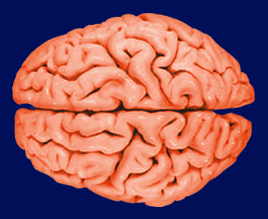
3
2
Knowledge-Base
(Free-Form Text)

search
knowledge
response

Expert/
Specialist
User

1



Experience

Textbook (pages 89-90)
creating knowledge
1

capturing and storing knowledge
2
3
disseminating knowledge

The Mother of Knowledge Management: Julia Child.
Read enough to figure out her role in knowledge management.

